Applications of Internet of Things (IoT)

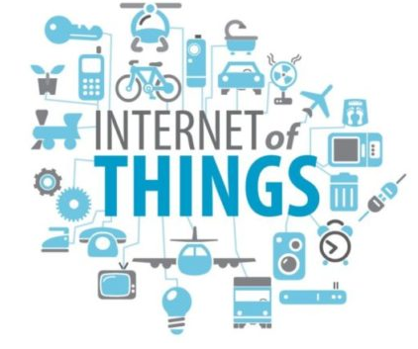

Internet, one of the most significant inventions of all time helped us to connect with people using computers and Smartphone. The new generation of network IoT (internet of things), connects things with the ability to sense, control and communicate.  Find out what are the applications of Internet of Things?

1. **Smart Home and Office**

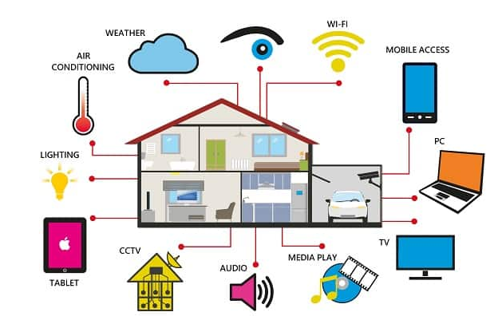Smart home applications with the use of smart sensors are becoming popular now. Any smart device can be configured and connected to the internet and control using simple mobile application.

**Smart Door access control system**

Smart locks and door access systems are one of the most popular and cost effective solutions of Internet of Things. Smart locks are easy to implement and control using a web interface or Smartphone application.

Integration with RDIF tags, smart door accessing systems can be securely implemented. Users can grant access to the doors using mobile app and lock again once the person leaves the premises.

Example: a person wants to enter your house while you are not around, you will be able to open the door for that person using Smartphone application.

**Smart lighting for home and office**

Smart lighting is one the attractive smart home application using internet of things. In addition to energy saving, it also enables us to manage effectively. Light ambience can be changed using smart hub devices or smart phone app.

Smart lighting can be configured to respond to voice commands and motion detectors / proximity sensors. These sensors will activate the light when someone enters the room or leaving the room.  Moreover, it can be configured to turn on when the ambient light is below certain threshold (turn on during sun light is low).

**Automated Gate and garage**

Using smart sensor technology and internet of things, gates and garages can be controlled (operated) conveniently. Once you are about to enter the house or after leaving the premises, you may open or close the gate using mobile devices.

**Smart thermostats and humidity controllers**

Smart thermostats are cost effective and convenient smart home solutions which can be controlled using an internet connection and smart hub device (or using Smartphone app).

Common sensors for home/office automation:

* Motion / proximity sensors
* Voice controlled sensor
* Light sensor
* Temperature and humidity sensors
* Smoke/fire sensor
* Precipitation sensor

**Traffic Management**

Analyzing traffic over a period of time gives an insight of possible trends and pattern that could occur during peak hours. It will help to inform commuters to take alternative routes to avoid congestion and delay.

**Smart lighting on streets**

Smart lighting is an effective solution to save energy in the cities. Smart sensors can detect presents of people or vehicles in the proximity and increase light intensity when someone pass by.

Once the person or vehicle is away from that area, smart light will automatically reduce light intensity to save energy. During emergency situations, maximum light intensity will be activated to support recovery activities.

Since the smart lighting systems are connected to control and monitoring network, any faulty light units will be automatically reported and necessary maintenance will be initiated.

**Pollution monitoring and reporting**

Increasing air pollution is one of the challenges we are facing in every growing cities. In order to solve this issue, smart sensors are deployed across the cities to continuously monitor any changes.

Some of the common sensors are temperature, air quality (like CO2 level, haze, and smoke), moisture etc…  Interconnected smart sensors collects data, sends these data to the monitoring stations and initiates warning messages during bad air quality detection.

**Smart Parking Solutions**

Smart sensors installed on parking area are collecting information about availability of parking slots and updating it to the database real time. Once the spot is occupied, it will be updated without any delay.

Service providers and customers can plan and manage parking issues with the use of smart parking solutions.

**Water / waste management**

Populations in cities are increasing every year, based on statistics this trend will grow in coming years. Increase in population contributes to increase in wastes as well.

Many cities are adapting recycling of water using water treatment units. With IoT system, the amount of waste water, consumption in a geographical area and trend of waste produced can be analyzed effectively.

IoT and smart sensor technology enables us to manage this issue efficiently. With smart waste management system, authorities will be able to predict the amount of waste produced in a particular location, how to process properly, trigger clearance of waste and analyze data for future planning etc.…

Example: smart sensors implemented on trash bins can send alerts to the waste management system once the bin is full (or reached threshold limit). If the waste quantity in the bin is low, it will not be emptied.

With analytics solutions, an overview of waste generated in every part of the city, how much wastes are generated in duration can be easily assessed. This information will be used to plan during the city expansion and upgrading projects.

Fleets for waste collection and treatment can be managed and any changing trends can be predicted via smart analytics solutions.

1. **Wearable Devices**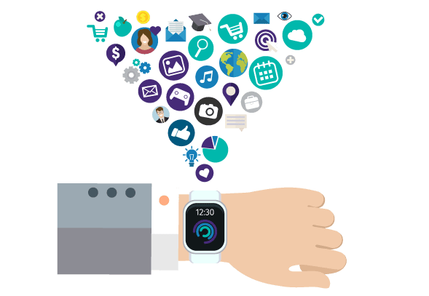

Wearable smart devices introduced as smart watches around a decade ago and many more functions were added since then.  Now our smart watches and wearable are capable of reading text messages, showing notifications of other apps, tracking location, monitor workout status, remind schedules and continuously monitoring health conditions.

With Internet of Things, wearable technology can be used beyond these functions.  Major smart wearable manufacturers are developing special operating systems and applications dedicated for smart wearable devices.

Many people have shared their stories how a smart watch saved their life during an accident and medical emergencies. Life saving applications makes smart wearable one of the most favorite devices among other IoT devices.

Parents can track their child’s location, care takers will get notification if patient’s vitals are low or blood sugar levels are changing. Doctors and medical professionals can continuously monitor their patient’s body conditions in real-time using wearable technology.

Future smart devices like smart watches and fitness bands will be optimized to perform more functions and connect with other smart IoT devices in smart home and other applications. Pairing with Smartphone applications will enable these smart wearable to initiate more tasks and get notified promptly.

**Future of Wearable technology**

Future wearable technology will be capable of early detection of diseases and trigger for treatment during early stages. Sensitive nano-sensors will have the capability to detect components in our body fluids (sweat, tear and saliva) and notify certain physical conditions that could trigger more severe disease in future.

Surgical implanted nano-sensors will give indication of possible medical conditions (like cancer) that could develop in our body before it become severe. Finding a medical condition in early stages has more effectiveness in treatment.

For example: if we are able to find out chances of developing diabetes before it affect our body, we can change our diet and seek medical advice to avoid or delay the decease as much as possible.

Future healthcare procedure will include more wearable devices for convenient, accurate detection of diseases and monitoring of many medical conditions.

1. **Healthcare**

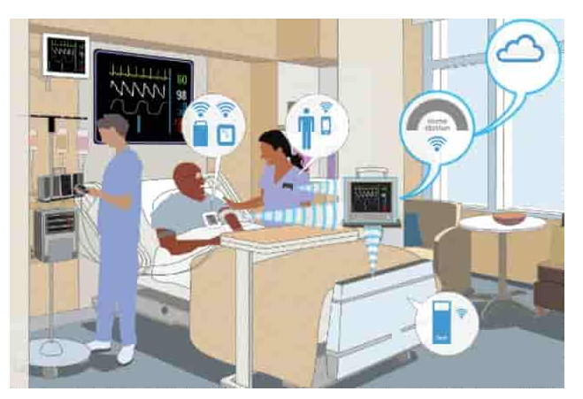

Healthcare industry has been utilizing the possibilities of Internet of Things for life saving applications. Starting from collecting vital data from bed side devices, real-time diagnosing process, accessing medical records and patient information across multiple departments, the entire system of patient care can be improved with IoT implementation.

IoT will offer convenience for medical practitioners, improve accuracy in the information (helps to reduce error in the data), increase overall efficiency and saves time for each procedures.

Doctors can monitor patient’s status remotely and suggest necessary procedures when required.

Data loss and mistakes will be reduced to a lower level with IoT devices. Most of the modern medical devices can be connected to the network and data can be accessed securely (In future, all devices will have the capability to connect the network).

Round the clock patient monitoring is possible with smart IoT devices. Immediate change in the vitals of a patient will automatically notify responsible medical practitioners real-time.

Doctors can prescribe medicine after assessing patient remotely with the help of smart IoT devices. In many cases, hospital visits many not be required.

Example: Many hospitals are offering telemedicine facility. Patients can follow-up treatment via video conferencing.

Apart from the efficiency and cost effectiveness of the healthcare systems, IoT also offers better patient satisfaction. Overall hospital experience will be improved with implementation of IoT in healthcare.

Find out more about how [wireless technology is used in Medicine and Healthcare](https://www.rfpage.com/how-wireless-technology-used-medicine-healthcare/)

1. **Autonomous Driving**

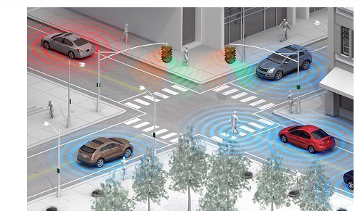

Autonomous driving has been evolving with the use of artificial intelligence and smart sensor technology in Internet of Things. Earlier generation of autonomous  vehicle (partial automation) will assists drivers to drive safely, avoid collisions and warn about the conditions of the road and vehicle.

Example: cruise control assistance, parking assistance, line changing assistance and efficient fuel /energy management etc.…

As we collect huge amount of data from thousands of vehicles (using millions of sensors and camera units), AI can predict certain scenarios on the road and help to implement in the future generation of vehicles for better safety and efficiency.

Self driving cars and connected car concept will offer a much safer road experience in future with the use of Internet of Things and artificial intelligence (AI). One of the significant components of IoT in automobiles is smart sensors which are continually collecting information about the vehicle, road condition, about other vehicles, objects on the road and road conditions.

The system consists of camera units, proximity sensors, RADARs, RF antenna arrays to collect information and help the vehicle to make decision based on the sudden changes on the road. Vehicles and smart objects can share information each other using RF technology.

Example scenarios: ice fall on road, vehicle breakdown / accident on one line and heavy traffic in a particular direction on highway etc.…

Accurate information is significant in making a split second decision while driving. There would be a bigger impact if the data is not accurate or delayed and it could even lead to fatal accidents.

5G technology offers faster data rate with low latency network which is curtail for autonomous driving technology.

Sophisticated algorithms are being developed to learn different scenarios from various conditions on the road. This powerful software with continuously learning AI, manufacturers can enhance the safety of the self driving (full automation) vehicles in future.

1. **Agriculture and Smart farming**

There are lot of challenges in the agriculture and farming industry to produce more crops and vegetable to feed increasing human population. Internet of Things can assists farmers and researchers in this area to find more optimized and cost effective ways to increase production.

In developed countries, young generation is not attracted to conventional farming and agriculture. Lack of support staff could lead to productivity; authorities have to find alternative ways to overcome this issue.

Internet of Things is one of the promising solutions to make entire agriculture and farming industry more efficient with less number of workers. Smart sensor technology will help improve each stages of agriculture and automation helps to reduce manual labor.

**Smart irrigation**

Smart irrigation is a method of efficient use of water for agriculture using Internet of Things. Smart sensors are deployed into soil which constantly monitoring and sending information about soil conditions to the control station.

Once the soil start to dry or reaches a threshold value defined by farmer, control system initiates the water flow and it will be stopped after a set time. Wastage or water and manual labor can be reduced by implementing automated irrigation system into agriculture.

**Smart Greenhouse using sensors**

Greenhouse farming is one of the successful agriculture methods to artificially controlling the environment for increased production of vegetables and fruits. Inside the green house, the essential parameters like **CO2 level**, **temperature** and **moisture** level are monitored round the clock and automatic precipitation, light and moisture control will be activated using IoT system.

This smart monitoring system control is much more efficient and cost effective than the same task performed by workers. The data collected using various sensors deployed in the greenhouse will be sent to the cloud, it helps to easily access the data for further analysis.

Predication farming is a method of applying useful information collected over duration of time for improved quantity and quality of agriculture products. Experts will analyze when would be the best time/season for farming, what should be best parameters for maximum productivity, suitable fertilizers and how to plan a particular product ready for harvest etc.…

**Smart Farming**

Internet of Things offers many solutions for convenient tracking of animals with the use of smart RFID tags. Farmers can easily record data of each animal with implementation of IoT and smart tags.

For example: movement (cow, sheep) from a particular location, age and weight of individual and vaccination details can be stored in database and easily accessed by just scanning the smart tag.

1. **Industrial IoT for manufacturing**

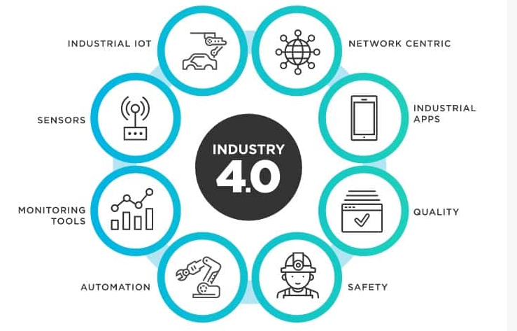

Image: tibco.com

Manufacturing industry is one of the early adopters of Internet of Things which entirely changed several stages of a product development cycle. Industrial IoT will help optimize various stages of product manufacturing such as:

* Monitoring of supply chain and inventory management
* Optimization in product development
* Automate mass production processes
* Quality testing and product improvement
* Improves packaging and management
* Process optimization using data collected from huge number of sensor networks
* Cost effective solution for overall management of factories

Find more about [applications of Industrial Internet of Things](https://www.rfpage.com/applications-of-industrial-internet-of-things/)

1. **Disaster management**

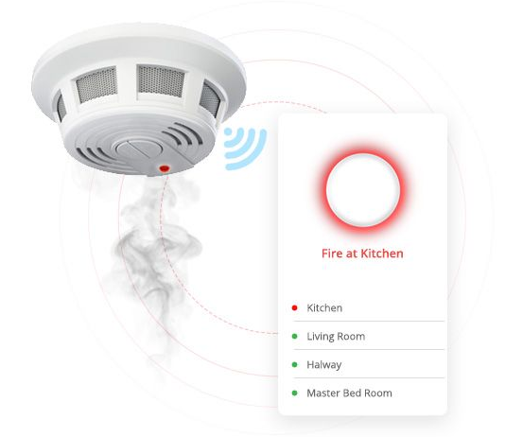

Internet of Things with wide range of smart sensors allow engineers to build a more effective emergency response system for factories, schools, hospitals, airports and any other public gathering places. Any emergency situations like fire outbreak or flooding will be automatically detected using sensors and this information is shared to responsible work groups in real time.

Disaster management team can respond effectively within seconds to start recovery operations. With better preparation plan, disaster management team can work safely and assist each individual to evacuate safely during an emergency situation.

During an emergency, fire department, emergency response volunteers, police force, ambulance units and nearby hospitals will receive an alert about the scenario. Automated warning system improves the preparedness and allows authorities to plan and handle any kind of situations immediately.

Some of the common sensors: smoke detector, temperature sensor, humidity sensor, CO2 monitoring sensors and precipitation detector.

Sensor deployed in many locations (where higher possibility of wildfire could happen) is continuously monitoring CO2 emission levels, fire and smoke. These smart sensors are connected to a network where any changes in the data will be immediately identified and alert warnings will be sent during a wildfire.

1. **Logistic and fleet management**

Smart logistics is a complex task since the goods must be handled with greater care and efficiency. Apart from moving from one location to another location, service providers have to make sure perfect condition is maintained during transportation.

Smart sensors capable of connecting to IoT network continuously monitoring the GPS location, temperature, humidity, shock and tilt angle of the container used for transpiration. Data collected from these sensors are processed and analyzed in a central cloud system.

Logistics team can access this information from anywhere using an internet connection. Movement of fleet can be monitored real-time and updated to customers about the progress of delivery.

Any delay during transportation will be notified to the responsible members of the team.

1. **Smart Grids and energy management**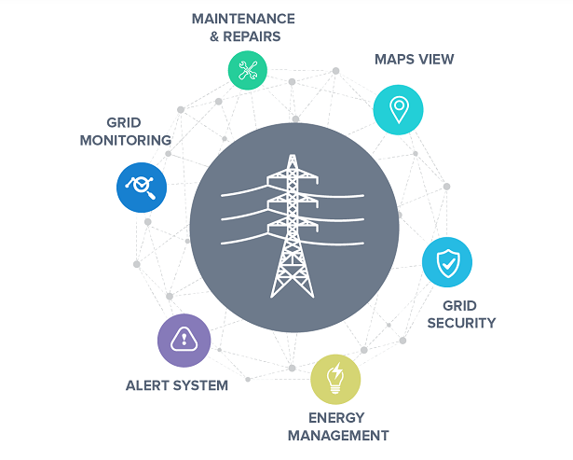

[Smart grid](https://www.webnms.com/iot/smart-power-grid.html) concept is an enhancement of existing power grids with sensors deployed on the transmission lines and individual customer outlets. Theses sensors helps to notify any failure, abnormality in the line, understand the nature of usage and behavior pattern over time.

These data can be used to find out areas of improvement, lossy nodes during transmission, and peak time usage statistics with the use of smart meters and sensors. Energy companies can use this information to improve existing grids and implement new changes during upgrade and thus reduce carbon emission.

In case one of the transmission line is down, smart sensors will automatically trigger to switch to another grid to provide uninterrupted supply. Manual action from a worker could take longer response time and this could cause long power outages and losses.

Customers also will benefit from implementation of IoT for energy management. With optimized use and energy saving, overall efficiency and energy wastage can be significantly reduced.

Example: Smart meters can notify customers about peak time usage cost and non peak time cost. Based on this data customers can schedule some tasks during non peak time to save energy cost.

1. **Big Data Analytics**

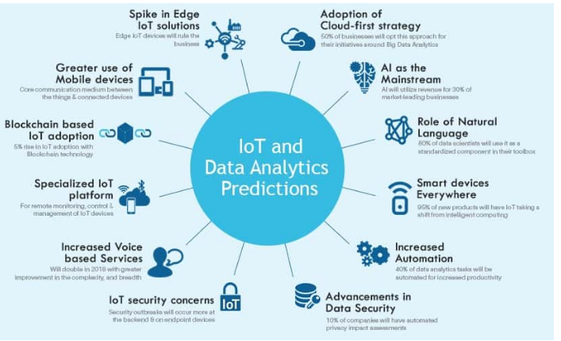

One of the basic components of big data analytics is the data itself; many organizations consider data as most valuable asset to grow their business strategies. The source of data could be from anywhere like machines, environment, plants, peoples or even animals.

Internet of Things uses hundreds of types of sensors designed to collect data from wide range of applications. Huge amount of data from millions of smart sensors will help big data analytics to improve its decision making algorithm using artificial intelligence and machine learning.

**Applications of Industrial Internet of Things**

### 1. Industrial Automation

Industrial automation is one of most significant and common application of Internet of Things. Automation of machines and tools enables companies to operate in an efficient way with sophisticated software tools to monitor and make improvements for next process iterations.

Accuracy of process stages can be improved to a greater level using machine automation. Automation tools like PLC (Programmable Logic Control) and PAC (Programmable Automation Control) are used with smart sensor networks connected to a central cloud system which collect huge amount of data. Specially designed software and applications are used to analyze the data and its behavior for improvements.

Industrial automation improves accuracy, efficiency; reduces errors, easy to control and remotely accessible via applications. Machines can operate at harsh environments than humans; automation of machines and tools reduces man power requirements for specific tasks.

#### Connected Factories

Connected Factory concept is an effective solution for improvements in all areas of operation. Major components such as machines, tools and sensors will be connected to a network for easier management and access. Overview of process flow, monitor down time, status checking of inventory, shipment, schedule maintenance and stop/pause a particular process for further analysis etc… can be done remotely using industrial IoT solutions.

### 2. Smart Robotics

Many companies are developing intelligent robotics system for IoT-enabled factories. Smart robotics ensures smooth handling of tools and materials in the manufacturing line with precise accuracy and efficiency. Predefined specifications can be set for maximum precision (up to few nanometers scale for some applications) using intelligent robotic arms.

Man machine interface design concept will reduce the complexity of operation and it will reflect in future IoT enabled manufacturing as improved productivity.

Robots can be programmed to perform complex tasks with high end embedded sensors for real-time analysis.  These robotics networks are connected to a secure cloud for monitoring and controlling. Engineering team can access and analyze this data to take quick actions for product improvements or preventing an unexpected failure due to machine fault.

### 3. Predictive Maintenance

Modern industrial machines equipped with smart sensors continuously monitoring the status of each major components and it can detect any critical issues before the system is completely down. Smart sensors will trigger maintenance warning to the centralized system and the alert messages will be delivered to responsible persons/groups.

Maintenance engineers can analyze the data and plan for schedules maintenance effectively without affecting routine task.

Predictive maintenance is an effective solution to avoid unnecessary downtime in the production line. Unexpected failure of machines could cause damage to products, delay in delivery and business loss for manufacturers.

Status of each machines are stored to a cloud system in a real-time basis. History of each machines, performance, and next scheduled maintenance are easily accessible remotely (on PCs, via web interface or via smartphone applications). Performance improvements can be calculated and implemented for each machines and process stages of products using collected data analysis.

### 4. Integration of Smart Tools / Wearables

Integration of smart sensors to tools and machines enables the workforce to perform the task with improved accuracy and efficiency. Specially designed wearables and [smart glass](https://www.engineering.com/AdvancedManufacturing/ArticleID/14634/Airbus-Uses-Smart-Glasses-to-Improve-Manufacturing-Efficiency.aspx) helps employees to reduce error and improve safety at the working environments.

Smart wearables can trigger instant warning messages to employees during emergency situations like gas leak or fire. Wearables can monitor health condition of individuals continuously and feedback if not fit for particular task.

### 5. Smart Logistics Management

Logistics is one of the important areas in many industries, which needs continuous improvements to support increasing demands. Smart sensor technology is a perfect fit to solve many of the complex logistics operations and manage goods efficiently.

Retail giants like Amazon using drones to deliver goods to their customers. Advanced technologies like drones offer better efficiency; accessibility, speed and it require less manpower. However, initials investments are huge compared to conventional methods and implementation has limitations.

Airline is another major industry, which uses IoT for its daily operations at the production and predictive maintenance of airplanes in service. At the manufacturing plant, airline companies use IoT solutions to track thousands of components required for every single day at work. Centralised management of inventories helps to manage its supplies effortlessly.

Suppliers will be automatically informed if any items are required to top up. Without much human action, inventory management can be effectively implemented using IoT.

Smart sensors continuously monitor airplane’s machineries, the data is collected real-time and send to the airplane manufacturer. Maintenance of any part of an airplane will be triggered, concerned team will be informed and maintenance will be carried out once the plane is landed without any delay. Manufacturers can plan and deliver spare parts efficiently based on the data shared by the system.

### 6. Software integration for product optimization

### Smart analytics solution is one of most important component of any IoT system which further enhances the possibilities of the system for improvement and optimization.

Major companies are implementing customized software for deep analysis of huge amount of data collected from large sensor networks and machines. Detailed analysis of data and understanding the behavior over time gives much better overview of process improvement strategies for product optimization.

Improvement ideas could be directly related to product recipe or optimization of particular machinery for better performance and output. Cost effective solutions can be achieved using analysis of data and its behavior patterns over a period of time. Analysis of huge amount of data was a hard, inaccurate and time consuming task before introduction of these software tools.

### 7. Smart Package Management

Package management using IoT technology gives lot of convenience and efficiency for manufacturing units. Smart sensors can monitor each stages of packing and update status in real-time manner. Embedded sensors can detect vibrations, atmospheric conditions like temperature and humidity etc… and feedback if something goes wrong during transit or storage.

### 8. Enhanced Quality and Security

Introduction of IoT technology in to manufacturing offers enhanced product quality. Continuous monitoring and analysis of each stages ensure better quality by improving process steps for optimum quality.

Integration of smart tools and software assisted procedures offer higher level of security. Software controlled automation and data collection from huge sensor network is connected to a highly secure gateway and cloud server platform.

Complex encryption techniques are used in IIoT platform for enhanced security.

### 9. Autonomous vehicles

Automotive industries are using IoT enables self driving vehicles to supply goods and logistics management within their company premises. Smart vehicles can detect traffic congestions along its path and make deviation to reach its destination is shortest time. These vehicles are equipped with many smart sensors continuously detect location data using GPS and [wireless technologies](https://www.rfpage.com/top-wireless-technologies-iot-5g-networks/) for communication with the control station.

### 10. Power Management

IoT can offer better solutions for power management in industries. Specific sensors can detect environment and trigger to turn on/off control of lights, air conditioners, humidity controls, liquid flow etc… for efficient power management.

#### Advantages of Industrial Internet of Things

* Improved accuracy
* Product and process optimization
* Predictive maintenance and analysis
* Higher efficiency
* Remote accessibility and monitoring
* Enhanced security
* Scalability of network
* Reduced down time for machines and process
* Power savings
* Cost effectiveness

# Industrial Internet of Things & Factories of the Future

# 

The manufacturing industry is undergoing a new age of evolution, with major changes occurring on multiple fronts. Companies keen on digital transformation are taking inspiration from the Internet of Things (IoT) to power their factories of the future. As a growing subcategory of IoT, the industrial Internet of Things (IIoT) leverages smart sensors and actuators to connect humans and machines with the Internet, boosting manufacturing and industrial processes in terms of efficiency, productivity, and safety. Along with cyber-physical systems (CPS), cloud computing and cognitive computing, the IIoT is key to building the Industry 4.0 era.

The market opportunities for IIoT are massive. [Markets & Markets](https://www.marketsandmarkets.com/Market-Reports/industrial-internet-of-things-market-129733727.html) reports the global IIoT market is expected to grow at a CAGR of 7.39 percent to reach US$91.4 billion by 2023, with the manufacturing industry holding the largest market share.

Successful adoption of IIoT systems is built on devices and technologies such as networking, sensors, RFID, cameras, GPS/GNSS, smart beacons and monitoring systems. AI-powered computer vision, machine learning, natural language processing and big data technologies are expected to continue to deliver breakthroughs in IIoT research, development and deployment.

# IIoT in manufacturing & Smart Factories

Widely applied in sourcing and production, assembly and packaging, warehousing and supply chain management, IIoT solutions enable a fully-connected factory where information and operational commands can be directly sent to suppliers, manufacturers and distributors. Smart factories can achieve improved manufacturing efficiency and quality, enhanced human activity support and reduced energy consumption and costs. Many industrial and tech companies are venturing into IIoT product development, aiming to bring innovative IIoT solutions to smart manufacturing.

**Siemens’s MindSphere** provides a “Predictive Maintenance” solution to manage the health of machines and maximize their performance. Through real-time monitoring and analysis of data from automation systems and production assets, the predictive maintenance system can evaluate machines’ health state and proactively identify the cause of any predicted machine breakdowns. MindSphere machine learning models for predictive analytics are built for each individual machine based on its historical health variables (e.g. vibration, temperature, cycles, load and pressure, etc.).

**ABB’s Ability** platform enables design, troubleshooting and optimization of a new production line using modeling and virtual commissioning without disturbing existing production operations. The system can build up a 3D process simulation wherein robots can be programmed and connected to automation networks, with all their operations tested in a virtual world. The solution can significantly enhance engineering efficiency and productivity with less risks and costs compared to deployment in a factory.

-------------------------------------------------------

# Brownfield IoT :

This article outlines the concepts of greenfield and brownfield and provides an overview of strategies for bringing IoT technologies to brownfield environments. After a brief look into current industry trends, the article offers a concrete solution.

How do you create value when it comes to the Internet of Things? While transitioning to [Industry 4.0](https://www.forbes.com/sites/bernardmarr/2018/09/02/what-is-industry-4-0-heres-a-super-easy-explanation-for-anyone/#54bff22d9788)is no longer simply a trend but a necessity, an ongoing concern for decision-makers is finding a solution that is actionable and feasible. And the difficulties begin with collecting data at the edge and communicating that data to the cloud.

### ****Challenges to brownfield development****

What is brownfield, then, and is it any better? [Brownfield](https://www.techopedia.com/definition/24409/brownfield) designates industrial or commercial property that is either underused or considered as a potential site for redevelopment. In urban planning, this is an area that has been previously built on. In software development, this is software building on heritage systems or created to work alongside already existing systems. Implementing IoT technologies in brownfield scenarios poses a [similar challenge](https://www.techopedia.com/definition/24409/brownfield).

Rather than freely building from scratch, one has to consider the existing architectures and work within pre-established constraints. Heightened implementation effort is needed here as well. The heritage hardware and software may have taken years to put in use and cannot simply be discarded. When it comes to the Industrial Internet of Things (IIoT), companies need to build on infrastructures that cannot be easily replaced or where a replacement is not commercially viable. The challenges pile up—taking legacy devices and connecting them to the cloud, maintaining connectivity, collecting data, and performing data analytics now take place within a highly heterogeneous landscape.

### ****Extending the brownfield with an IoT platform****

To say that implementing brownfield IoT technologies is challenging would be an understatement. Within an increasingly diversified IoT landscape, however, finding actionable IoT brownfield solutions gets all the more interesting. Services such as[Record Evolution IoT development studio](https://www.record-evolution.de/en/reswarm-iot-development-studio/)—our IoT platform that acts as an end-to-end enabler integrating an app development studio with a device management suite—allow IoT devices to seamlessly connect, bringing forth their functionality and power within a heterogeneous landscape.

The platform allows you to connect legacy devices coming from different vendors as well as devices belonging to different generations. Our aim has been to facilitate communication between both intra-gen and cross-vendor devices. Further, our purpose is to anticipate next-gen advancements and make our platform ready to accommodate future products. On the platform, you have adevice management studio where you create and connect individual IoT devices or device groups, re-group your existing IoT devices, or generate different group levels where a device can belong to several classification groups simultaneously.

## ****Strategies for the brownfield****

Arming facilities with brownfield IoT technologies for more IoT connectivity is a transformation process that can be seen from several different angles.

### ****Retrofitting****

Wolfgang Thieme, Chief Product Officer at BTI, [enumerates current approaches](https://iiot-world.com/connected-industry/3-practical-ways-to-transform-brownfield-plants-into-digital-factories/), the most prominent of which is outfitting existing infrastructure with smart sensors to collect data on the shop floor. In this scenario, an IoT gateway aggregates data from remote sensors and communicates the data to the cloud. Retrofitting legacy assets—including assets that have no history of prior sensor capabilities—with current IoT sensors is one step towards becoming IoT-ready.

Smarts Objects

The concept of smart in IOT is used for physical objects that are active, digital, networked, can operate to some extent autonomously, reconfigurable and has local control of the resources. The smart objects need energy, data storage, etc.

A **smart object** is an object that enhances the interaction with other smart objects as well as with people also. The world of IOT is the network of interconnected heterogeneous objects (such as smart devices, smart objects, sensors, actuators, RFID, embedded computers, etc.) uniquely addressable and based on standard communication protocols.

In a day to day life, people have a lot of object with internet or wireless or wired connection. Such as:

* Smartphone
* Tablets
* TV computer

These objects can be interconnected among them and facilitate our daily life (smart home, smart cities) no matter the situation, localization, accessibility to a sensor, size, scenario or the risk of danger.

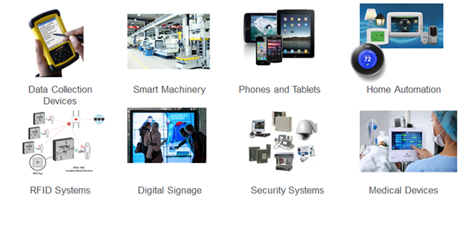

Smart objects are utilized widely to transform the physical environment around us to a digital world using the Internet of things (IOT) technologies.

A smart object carries blocks of application logic that make sense for their local situation and interact with human users. A smart object sense, log, and interpret the occurrence within themselves and the environment, and intercommunicate with each other and exchange information with people.

The work of smart object has focused on technical aspects (such as software infrastructure, hardware platforms, etc.) and application scenarios. Application areas range from supply-chain management and enterprise applications (home and hospital) to healthcare and industrial workplace support. As for human interface aspects of smart-object technologies are just beginning to receive attention from the environment.

---------------------------------------------------------------------------

### What are Smart Applications?

Smart applications are those applications that incorporate data-driven, actionable insights into the user experience. Insights are delivered in context as features in applications that enable users to more efficiently complete a desired task or action. They often take the form of recommendations, estimates, and suggested next actions. Smart applications can be consumer-facing or employee-facing. In some cases, the “user” is not a human, but a machine or system. In these cases, smart applications automate business and operational processes based on data-driven insights.

For example, retail smart applications make product recommendations based on analysis of customer buying behavior while logistics applications provide data-driven estimates of deliverytimes of goods and products. Healthcare smart applications offer possible patient diagnosis and treatment recommendations to clinicians based on analyses of patient and research data.

### Why Smart Applications Matter

|  |  |  |
| --- | --- | --- |
| ◼ |  | **Smart applications operationalize insights** No matter how effective your data science capabilities, data-driven insights hold no value if they can’t be operationalized and acted upon. Smart applications surface insights in context to users and systems, so they can take corresponding actions. |
| ◼ |  | **Personalize the customer experience** Today’s customer expects to be treated as an individual by the companies or organizations she interacts with, regardless of industry. By surfacing tailored insights, smart applications personalize the user experience, leading to higher customer loyalty and reduced customer churn. |
| ◼ |  | **Optimize customer interactions** Smart applications that deliver tailored insights enable enterprises to nudge customers and users to take specific actions that lead to desired outcomes in support of both tactical and strategic business goals. |
| ◼ |  | **Improve operational efficiency** Machine-to-machine IoT smart applications coupled with event-driven architectures allow enterprises to improve efficiency by intelligently automating operational processes based on real-time insights. |
| ◼ |  | **Enable new business models** Smart applications help enterprises in traditional industries, such as retail, financial services and transportation, develop new business models based on software, data, and predictive insights.    **STUDY OF** **EXISTING** **INTERNET OF THINGS PLATFORMS**  "Internet of Things" (called IOT), associated with the concept of "future internet" is a vision where each object will become a part of the Internet. Here objects can be any living entity like humans or animals and any non-living entities on earth. IoT is like a vision in which every object which is on network can uniquely be identified, its status and position can be known, it is accessible to the network and also services and intelligences are added to this network. So it fuses real world with virtual world of digital technology and impacts our social, personal as well as professional life. IOT will change the information world and technology world drastically to make a more comfortable world full of technology for us. Various prototyping hardware boards, on chip systems, sensors, RFID and ubiquitous networking capabilities are supporting candidates for IOT evolution [1]. In this section, IOT platform and IOT middleware are elaborated. In section-II, various popular IOT platforms are discussed and then they are compared in section-III. At last the paper is concluded in section-   * 1. Internet of Things platform Platform:     When you are developing some application, Platform is one which allows you to deploy and run your application. A platform could be a hardware plus software suite upon which other applications can operate. Platform could comprise hardware above which Operating system can reside. This Operating system will allow application to work above it by providing necessary execution environment to it. [3]  IOT platforms (more specifically IOT application platforms) provide a comprehensive set of generic, i.e. application independent functionalities which can be used to build IOT applications. [4] When there is only one communication link between devices of one type with another device of same type then, a system of specific service can be set up. But in case of communication among devices of multiple types, there is a need of some common standard application platform which hides heterogeneity of various devices by providing a common working environment to them. [5] An IOT application platform is a virtual solution, means it resides over cloud. Data is the entity that drives business intelligence and every device has something to talk with other device that is data. By means of cloud connectivity, IOT application platform translates such devices data into useful information. So it provides user means to implement business use cases and enables predictive maintenance, pay-per-use, analytics and real time data management. Thus, IOT application platforms provide a complete suite for application development to its deployment and maintenance.  1.2. Internet of Things middleware:    Middleware provides a wide variety of services to the applications from outside. So the application is not bound to use its all services but only uses the necessary set of services. It acts as a middle level agent between the service provider and service consumer. It allows communication among the application that come from different vendors or runs on different platform. It acts as a mediator between applications of different forms. [3] IoT middleware is a mechanism that joints different components of IoT systems together and offers smooth communication among devices and components. It is an interface that is available to provide interaction between Internet and Things. Here things may be hardware or some application. [6] IOT middleware aims to hide the heterogeneity of different hardware and software and enables the use of common platform so that the system is easy to use and manage. Thus, IOT middleware is a mediator suite which hides heterogeneity among devices, components and technology of an IOT system.  1.3. Internet of Things platform Vs. Internet of middleware:IOT platform is a complete suite of services that facilitates services like development, deployment, maintenance, analytics as well as intelligent decision making capabilities to an IOT application. International Journal of Computer Science & Engineering Survey (IJCSES) Vol.6, No.6, December 2015 63 Whereas IOT middleware is a service suite which is mainly intended to overcome the heterogeneity problem of the entire IOT system by enabling smooth communication among devices and components of different vendors and different technology.  ----------------------------------------------------------------------------- |